Warehouse Management (WM)
Case Study I
This case study explains an integrated warehouse management process which is triggered by a purchase order for a warehouse-managed storage location.

Product  SAP ERP  G.B.I.  Release 6.07  Level  Beginner  Focus  Warehouse Management  Authors  Simha Magal  Stefan Weidner  Chris Bernhardt  Version  2.40  Last Update  June 2015 | MOTIVATION  Warehousing has significant value for logistics.  Current trends such as higher cost pressure, shorter cycles of innovation, higher customer expectations and globalization of markets make great demands on companies, in particular on warehouse logistics. This is especially difficult in industries with high differentiation like the consumer goods industry. Furthermore, customers have increasingly higher demands on reliability, promptness and flexibility of deliveries.  Warehouse management systems support the global flow of goods between the producer and the purchaser and facilitate near fail-proof logistic operations in increasingly complex supply chains. |  | PREREQUISITES  Before you use this case study, you should be familiar with navigation in the SAP system.  In order to successfully work through this case study, it is not necessary to have finished the WM exercises. However, it is recommended.  NOTES  This case study uses the Global Bike Inc. (G.B.I.) data set, which has exclusively been created for SAP UA global curricula.



 | Process Overview
Learning Objective Understand and perform a warehousing process for ext. goods Time 70 min
Scenario Due to increasing sales output in your San Diego distribution center, the management has decided to install a Warehouse Management System there. These adjustments have just been completed. Now the new system needs to be tested. For this purpose, trading goods shall be procured from a vendor and put in stock in San Diego using the new warehouse management system.
Employees involved Tirrell Winsten (Buyer)
Wilton Saban (Iventory Supervisor)
Carolin Bruzik (Warehouse Supervisor)
Sunil Gupta (Warehouse Employee)
Yoshi Agawa (Receiving Clerk)
In order to receive goods from a vendor you need to create a purchase order. Then, goods will be sent from the vendor to the distribution center. As soon as you register the receipt of the goods in San Diego, you will create a transfer order for the received goods. Due to this order, the Warehouse Management will put the goods into stock. In conclusion, you will check if the goods were sorted into the correct storage bins. Because this case study focuses on Warehouse Management detailed instructions of how to receive the invoice and how to pay the vendor are not included. However, you may use respective parts of the Materials Management (MM) case study to finalize the procurement process and see the financial impact. |  | Process description
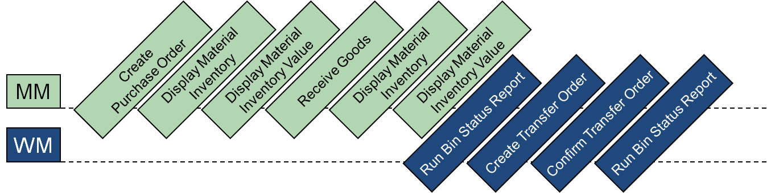

 | Step 1: Create Purchase Order
Task Create a purchase order. Time 10 min
Short Description Use the Easy Access Menu to create an immediate purchase order for materials from a vendor, i.e. to start the procurement process without having created a purchase requisition before.
Name (Position) Tirrell Winsten (Buyer)
To create a purchase order, follow the menu path:  Logistics ► Materials Management ► Purchasing ► Purchase Order ► Create ► Vendor / Supplying Plant Known |  | Menu path
In the Create Purchase Order screen, change the type of purchase order to Standard PO and enter 103### (replace ### with your number) as Vendor. Confirm your entries by clicking or Enter and accept any warning messages with Enter. |  | Standard PO  103###
Then, fill in US00 as Purch.Org., N00 as Purch. Group and US00 as Company Code. |  | US00  N00  US00
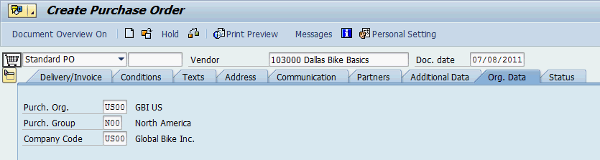
Select to expand the Item Overview. Enter KPAD1### as Material (replace ### with your number), 50 as PO Quantity, SD00 as Plant, TG00 as Storage Location, 40 USD as Net Price and 8 days from today as Delivery Date.  In the next row, repeat your entries but choose EPAD1### as Material. Confirm your entries by clicking or pressing Enter. |  | KPAD1###  50  SD00  TG00  40  8 days from today  Repeat for EPAD1###
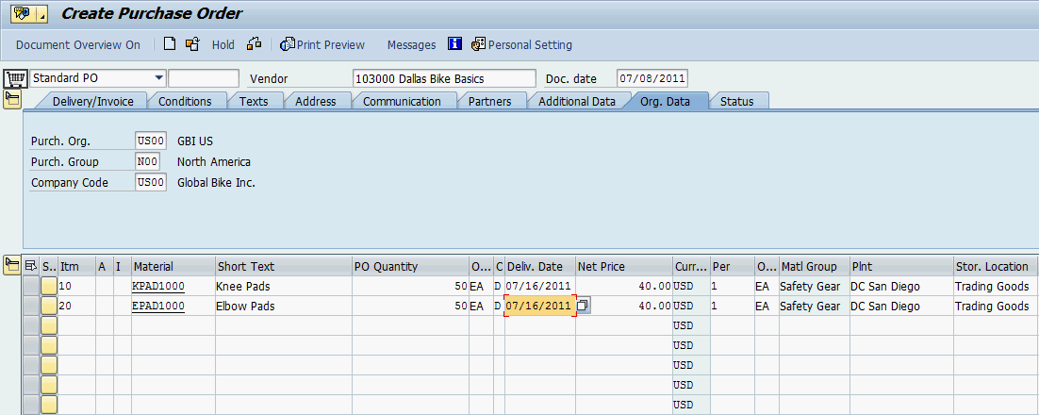
Compare your entries with the screenshot above.
Then, click on to save your order. The system will assign a Standard PO document number. |  | Purchase Order  Document Number
Click on the exit icon to return to the SAP Easy Access screen.

 | Step 2: Display Material Inventory
Task View the inventory of your material. Time 5 min
Short Description Use the Easy Access Menu to display the inventory of your material.
Name (Position) Wilton Saban (Iventory Supervisor)
To display the material inventory, follow the menu path:  Logistics ► Materials Management ► Inventory Management ► Environment ► Stock ► Stock Overview |  | Menu path
In the Stock Overview screen, enter KPAD1### as Material (remember to replace ### with your number). Ensure that all other search criteria fields are blank and click on . |  | KPAD1###
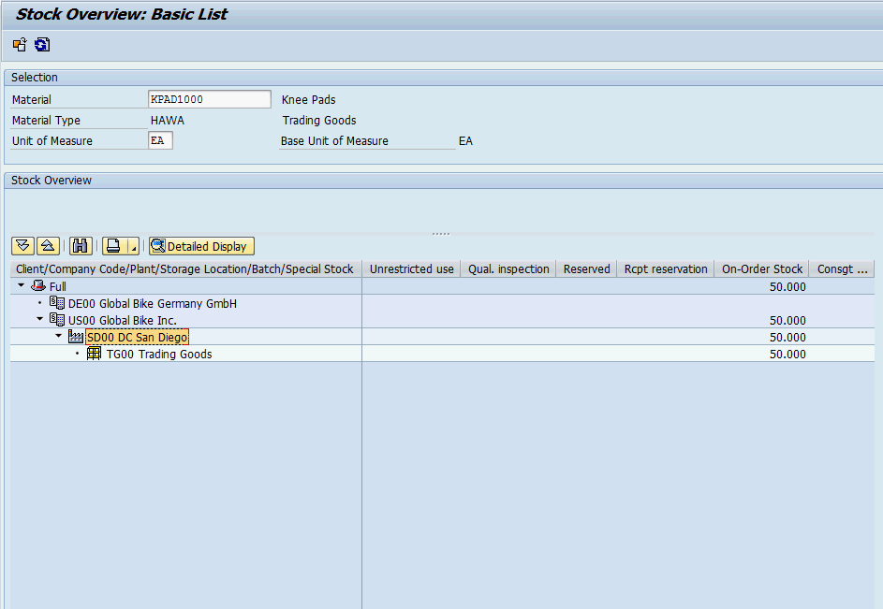
Note that the amount of your good in San Diego is zero. However, after double clicking on SD00 DC San Diego you can see that you have an On-Order Stock balance of 50 for your distribution center.
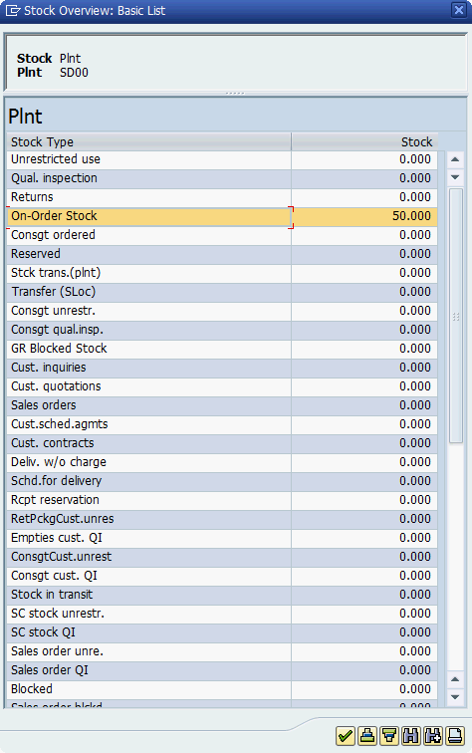
Repeat this task for the material EPAD1###. |  | Repeat for EPAD1###
Click on the exit icon to return to the SAP Easy Access screen.

 | Step 3: Display Material Inventory Value
Task View the value of your material inventory. Time 5 min
Short Description Use the Easy Access Menu to display the value of your material inventory.
Name (Position) Wilton Saban (Iventory Supervisor)
To display the material inventory value, follow the menu path:  Logistics ► Materials Management ► Inventory Management ► Environment ► Stock ► Warehouse Stock |  | Menu path
In the Display Warehouse Stocks of Material screen, enter KPAD1### as Material (remember to replace ### with your number). Ensure that all other search criteria fields are blank and click on . |  | KPAD1###
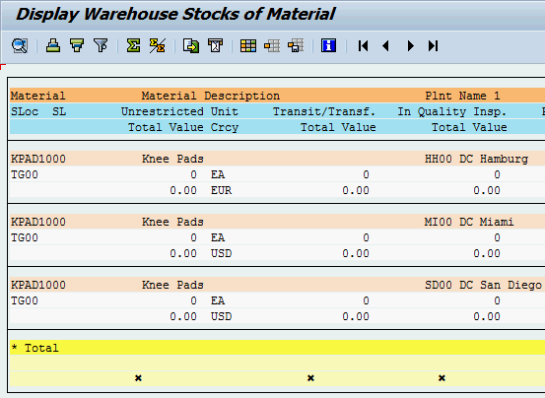
You can see that all values listed for this material are currently zero.
Repeat this task for the material EPAD1###. |  | Repeat for EPAD1###
Click on the exit icon twice to return to the SAP Easy Access screen.

 | Step 4: Receive Goods
Task Receive goods at receiving plant. Time 5 min
Short Description Use the Easy Access Menu to create a goods receipt which documents the receiving of your materials in San Diego.
Name (Position) Yoshi Agawa (Receiving Clerk)
To create a goods receipt, follow the menu path:  Logistics ► Materials Management ► Inventory Management ► Goods Movement ► Goods Receipt ► For Purchase Order ► PO Number Known |  | Menu path
In the Goods Receipt Purchase Order – Username screen, change the Material Document drop down to Goods Receipt, adjust the type of Goods Receipt to a Purchase Order, and input your Purchase Order Number in the blank space next to it. |  | Goods Receipt  Purchase Order  PO number
If you have not written down the PO number you created in the first task, you may use the F4 help in the PO number field (first blank field next to the second drop-down field).  In the following screen, use to choose the Purchasing Documents for Material tab. Then, enter KPAD1### as Material and press Enter. |  | KPAD1###
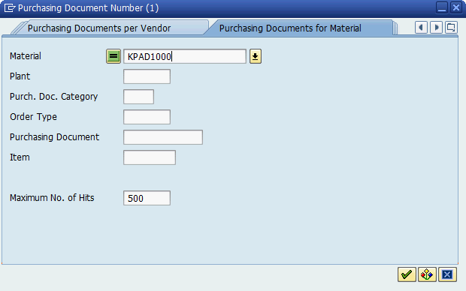
Now double click on your entry.
After your order number is filled in, please blank out the position field (field behind your order number).

Note: If you do not clear this field, only one of the two line items of your purchase order may be transferred.
Then, click on or press Enter.
After your purchase order data comes up select the check boxes in the OK column. If one of the boxes is grayed out click on to close the Detail Data Screen. Make sure that Quantity is 50, SLoc is TG00, Movement Type is 101 and Stock Type is Unrestricted Use. |  | OK  50  TG00  101  Unrestricted Use
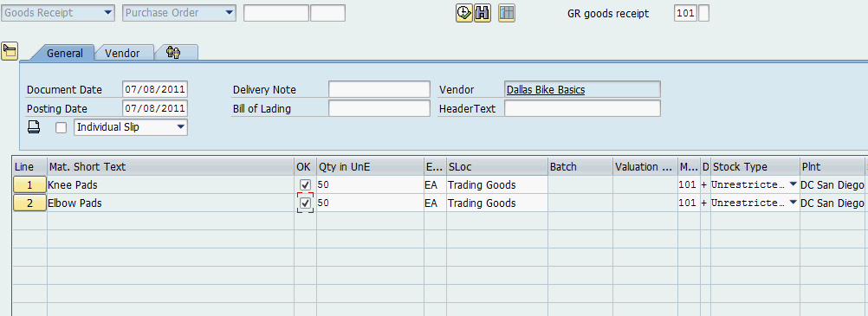
Then, click on to save your receipt. The system will assign a unique material document number. |  | Material document number
Click on the exit icon to return to the SAP Easy Access screen.

 | Step 5: Display Material Inventory
Task View the inventory of your material again. Time 5 min
Short Description Use the Easy Access Menu to display the inventory of your material again.
Name (Position) Wilton Saban (Iventory Supervisor)
To display the material inventory, follow the menu path:  Logistics ► Materials Management ► Inventory Management ► Environment ► Stock ► Stock Overview |  | Menu path
In the Stock Overview screen, enter KPAD1### as Material (remember to replace ### with your number). Ensure that all other search criteria fields are blank and click on . |  | KPAD1###
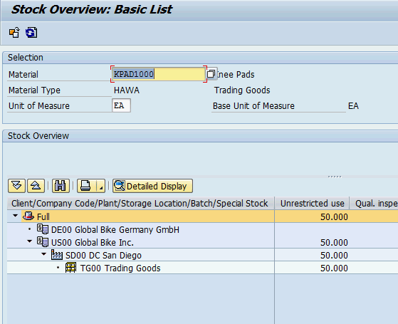
Note that the amount of your good for unrestricted use in San Diego has changed now. By double clicking on SD00 DC San Diego you can also see that your On-Order Stock balance is zero now.
Repeat this task for the material EPAD1###. |  | Repeat for EPAD1###
Click on the exit icon to return to the SAP Easy Access screen.

 | Step 6: Display Material Inventory Value
Task View the value of your material inventory again. Time 5 min
Short Description In this step, you will use the Easy Access Menu to display the value of your material inventory again.
Name (Position) Wilton Saban (Iventory Supervisor)
To display the material inventory value, follow the menu path:  Logistics ► Materials Management ► Inventory Management ► Environment ► Stock ► Warehouse Stock |  | Menu path
In the Display Warehouse Stocks of Material screen, enter KPAD1### as Material (remember to replace ### with your number). Ensure that all other search criteria fields are blank and click on . |  | KPAD1###
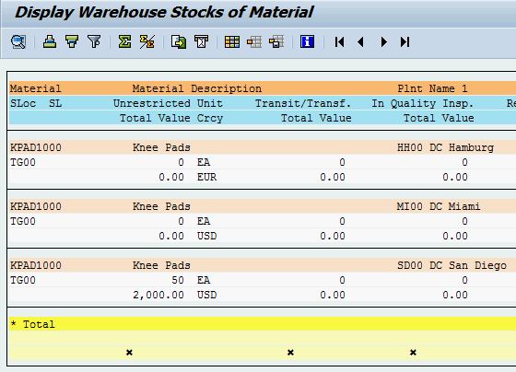
As you can see the value for the 50 units of your material has been added to the distribution center in San Diego.
Repeat this task for the material EPAD1###. |  | Repeat for EPAD1###
Click on the exit icon twice to return to the SAP Easy Access screen.

 | Step 7: Run Bin Status Report
Task Check the status of your bins. Time 5 min
Short Description Use the Easy Access Menu to run a bin status report which will display a detailed report of each storage bin within the specified warehouse.
Name (Position) Carolin Bruzik (Warehouse Supervisor)
To run a bin status report, follow the menu path:  Logistics ► Logistics Execution ► Internal Whse Processes ► Bins and Stock ► Display ► Bin Status Report |  | Menu path
In the Bin Status Report: Initial Screen, enter 100 (for your San Diego Warehouse) as Warehouse Number and STBN*### as Storage bin (replace ### with your number). Then, click on . |  | 100  STBN*###
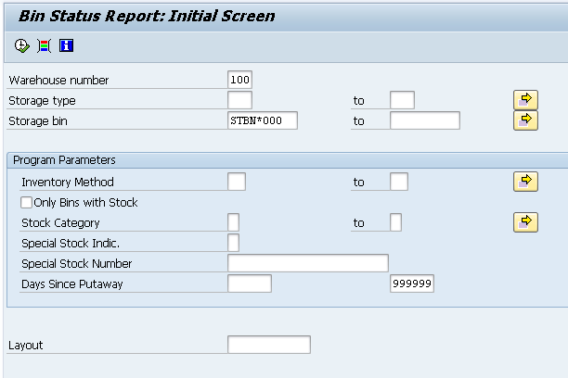
In the Bin Status Report: Overview screen you should see a list of all your storage bins for the entire warehouse in San Diego. Double click on one of your storage bins to get detailed information. As you can see the ordered materials are note present yet. Currently they are located in temporary bins.
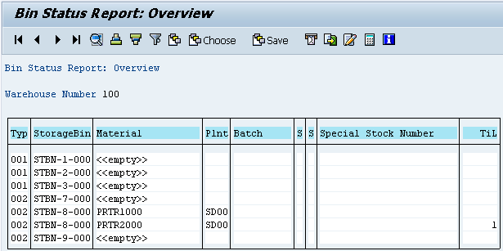
Click on the exit icon twice to return to the SAP Easy Access screen.

 | Step 8: Create Transfer Order
Task Create a transfer order. Time 10 min
Short Description Use the Easy Access Menu to create a transfer order to place your goods into your storage bin. It is a handoff from inventory management to warehouse management. The system recognizes that there are goods that have been received, but need to be put away.
Name (Position) Sunil Gupta (Warehouse Employee)
To create a transfer order, follow the menu path:  Logistics ► Logistics Execution ► Inbound Process ► Goods Receipt for Purchase Order, Order, Other Transactions ► Putaway ► Create Transfer Order ► For Material |  | Menu path
In the Display Transfer Requirement: List of Material screen, enter 100 (for your San Diego Warehouse) as Warehouse Number, KPAD1### as Material (replace ### with your number) and SD00 as Plant. Then, click on or press Enter. |  | 100  KPAD1###  SD00
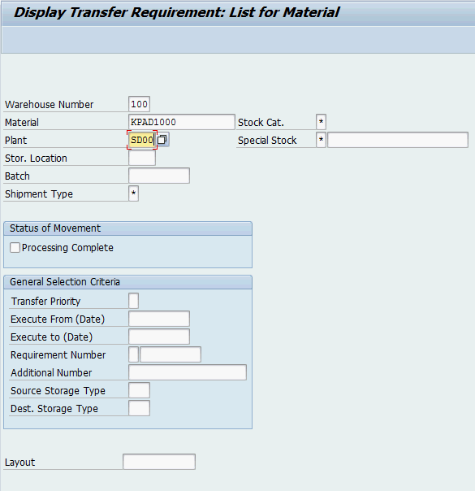
In the Transfer Requirements for Material screen, you should see a line item describing the goods just received for your purchase order. The requirement number should be the same as the purchase order number you received earlier. Make sure that the line item is selected and click on the button.
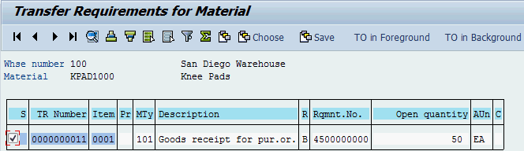
In the Create TO for TR 00000000XX 0001: Prepare for Putaway screen, hit or Enter to copy your quantity of 50 from the Palletization section to the Items section. Enter 001 as Sec, STBN-1-### as Destination Bin (replace ### with your number) and use F4 to select Shelf Storage as Type. Confirm your entries by clicking or pressing Enter. |  | 001  STBN-1-###  001 (Shelf Storage)
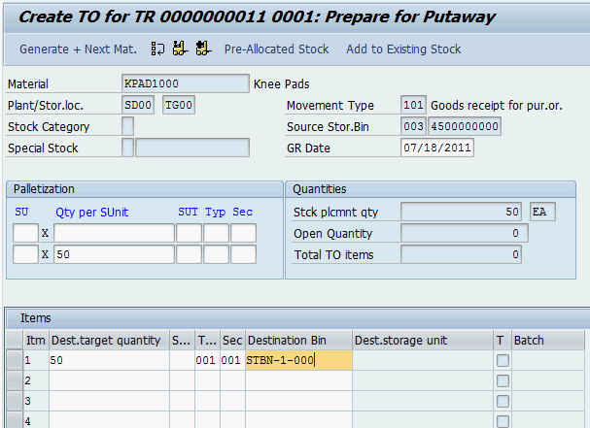
Then, click on to save your transfer order. If any warnings occur ignore them by pressing Enter. The system will assign a unique transfer order number.  Please write down this number. |  | Transfer Order Number
Repeat the whole procedure for your material EPAD1### to put it in the same storage bin.
Click on the exit icon twice to return to the SAP Easy Access screen.

 | Step 9: Confirm Transfer Order
Task Confirm your transfer order. Time 10 min
Short Description Use the Easy Access Menu to confirm the transfer order you created in the previous step. This is confirming that the goods are physically in the storage bin indicated in the transfer order.
Name (Position) Sunil Gupta (Warehouse Employee)
To confirm a transfer order, follow the menu path:  Logistics ► Logistics Execution ► Inbound Process ► Goods Receipt for Purchase Order, Order, Other Transactions ► Putaway ► Confirm Transfer Order ► Single Document ► In One Step |  | Menu path
In the Confirm Transfer Order: Initial Screen, enter the Transfer Order Number from the previous task and 100 as Warehouse Number. Then click on or press Enter. |  | Transfer Order Number  100
Note: If you have not written down the number you can search for it using the transaction code LT23.  In the Transfer Orders: List of Resident Documents you have to fill in 100 as Warehouse number. Then, click on . |  | 100
In the Confirm Transfer Order: Overview of Transfer Order Items screen you should see an overview of your transfer order created in the previous step. Review all of the details to make sure you have the correct quantity and storage bin.
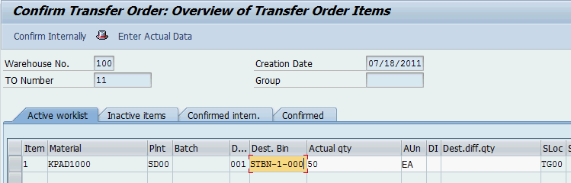
Then, click on to confirm your transfer order. The system will return a success message.
Repeat this step for your other transfer order number (second material). |  | Repeat for second Transfer Order
Click on the exit icon to return to the SAP Easy Access screen.

 | Step 10: Run Bin Status Report
Task Check the status of your bins again. Time 5 min
Short Description Use the Easy Access Menu to run a bin status report, which will display a detailed report of each storage bin within the specified warehouse.
Name (Position) Carolin Bruzik (Warehouse Supervisor)
To run a bin status report, follow the menu path:  Logistics ► Logistics Execution ► Internal Whse Processes ► Bins and Stock ► Display ► Bin Status Report |  | Menu path
In the Bin Status Report: Initial Screen, enter 100 (for your San Diego Warehouse) as Warehouse Number and STBN*### as Storage bin (replace ### with your number). Then, click on . |  | 100  STBN*###
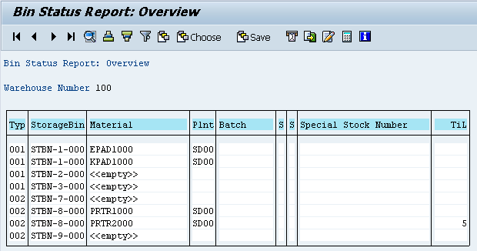
In the Bin Status Report: Overview screen you should see that the StorageBin STBN-1-### is filled now. Click on one of your storage bins to display detailed information and check whether 50 of each of your goods are stored in it.
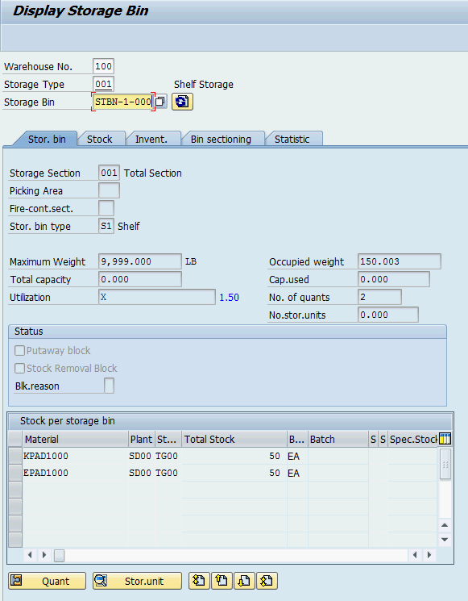
Note: As you can see each of the materials is dedicated to an own quant within the storage bin you have selected.
Click on the exit icon to return to the SAP Easy Access screen.

WM I Challenge
Learning Objective Understand and perform a warehousing process for ext. goods Time 70 min
Motivation After having finished the Warehouse Management I case study successfully you should now be able to solve the following challenge.
Scenario The warehouse management system has been tested without any problems, so the management decided to use the system productively. Now your task is to order two different products (water bottles and road helmets) from the supplier Spy Gear, 50 pieces each. A water bottle will cost 11 USD and a road helmet will cost 27 USD. The trading goods should be delivered in 8 days.
After the goods arrived in your Distribution Center in San Diego they need to be transferred in two different bins.
Task Information You can use the Warehouse Management I case study as a guideline but it is recommended to complete this challenge without further assistance to prove your WM skills.

